

**GREEN PEACE ACADEMY**

A Lab Report On DBMS



Submitted by: Ashish Uraw

Submitted to:

**Computer Science Department**

22 Falgun, 2081

**Introduction:**

A Database Management System (DBMS) is a software tool designed to help users efficiently create, store, and manage databases. It ensures structured data organization while maintaining security, accuracy, and consistency. DBMS is widely used in various domains, ranging from small applications to large-scale enterprise systems.

This lab focused on essential DBMS concepts such as database structuring, SQL queries, normalization techniques, and transaction handling. By the end of the lab, I’ve gained practical experience in designing databases, executing queries, and understanding efficient data management.

**Software/Tools Used:**

**Vs Code:** Visual Studio Code (VS Code) is a powerful, lightweight code editor used for various programming languages and development tasks

**XAMPP:** is a free and open-source software package that provides an easy way to set up a local web server for development and testing purposes. It is used have a database server

**phpMyAdmin:** It is a free and open-source web-based application used to manage MySQL databases. It is used to easily create, manage, and delete databases through a web browser.

**Basic Statements/Commands Used:**

CREATE DATABASE: It is used to create a new database in DBMS.

CREATE TABLE: creates table in database

INSERT INTO: Insert records into the table

SELECT FROM: Retrieves data from the table

**Lab report: Chapter 1- DBMS**

**a. Create a database named ‘computer_science’.**

CREATE DATABASE computer science.

Output:

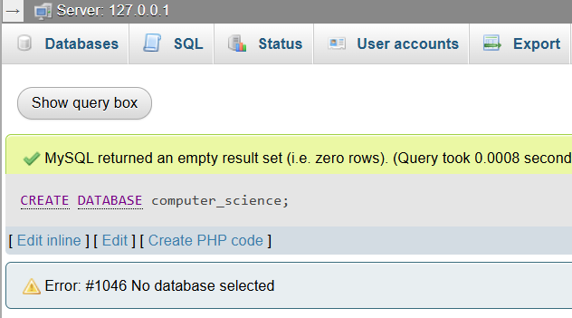

**b. Create a table named ‘Students’ under the database ‘computer_science’ and insert any 5 records:**

USE computer_science;

CREATE TABLE Students (

Roll Number INT PRIMARY KEY,

Name VARCHAR(100),

Gender VARCHAR(10),

Address VARCHAR(200),

Contact VARCHAR(15)

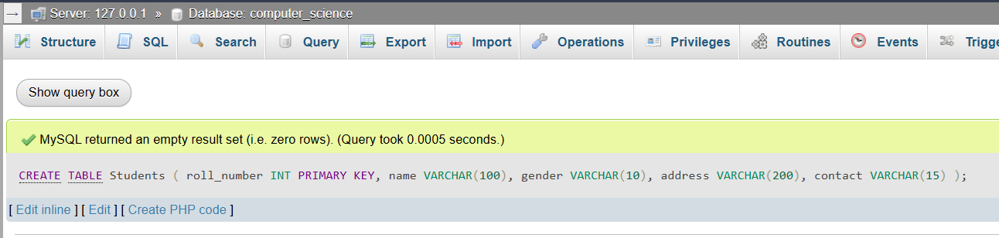);

INSERT INTO Students (RollNumber, Name, Gender, Address, Contact)

VALUES

(1, 'Arun Uraw', 'Male', 'Kathmandu', '9812345678'),

(2, 'Kirti Kumari', 'Female', 'Pokhara', '9812345679'),

(3, Alex Rai', 'Male', 'Bhaktapur', '9812345680'),

(4,Puja Shah', 'Female', 'Lalitpur', '9812345681'),

(5,Messi Karki', 'Male', 'Chitwan', '9812345682');

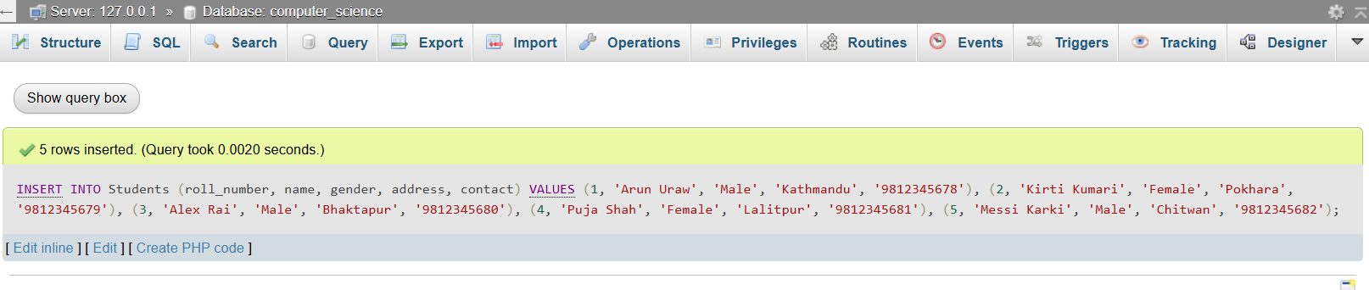Output:

**c. Display all the records:**

To display all records in the Students table, we can use the SELECT statement:

**SELECT * FROM Students;**

Output:

**d. Display the Record of the students whose name starts with ‘A’:**

To filter records based on names starting with ‘A’, we can use the LIKE operator:

**SELECT * FROM Students**

**WHERE Name LIKE 'A%';**

Output:

**Conclusion:**

"This lab session provided a solid understanding of the core SQL operations, including creating databases, defining tables, and inserting records. Through hands-on exercises, I gained practical experience with key SQL commands like CREATE, INSERT, SELECT, and WHERE, which are essential for managing and querying data. Mastering these concepts is crucial for anyone working with databases and plays a vital role in software development, particularly in tasks related to Database Management Systems (DBMS)."



**Introduction:**

JavaScript is a programming language used to make websites interactive and dynamic. It runs in the browser and is essential for front-end development, allowing you to respond to user actions like clicks or form submissions. In this lab I learned basic syntax, function and uses of loops. By the end I understand how JavaScript makes websites more interactive and user-friendly.

**Software/Tools Used:**

**VS Code:** Visual Studio Code (VS Code) is a powerful, lightweight code editor used for various programming languages and development tasks.I use Visual Studio Code (VS Code) in this lab for writing, editing, and testing JavaScript code.

**Live Server** (**vs code extension):** A simple extension that allows to run a local development server and view changes in real-time on your web page as you edit the code.

**Chrome Browser:** Google Chrome is a fast, secure, and widely used web browser developed by Google. It is known for its simple interface, high performance, and strong security features.

**Basic Statements/Commands Used:**

If else statement: It is used to execute code based on conditions.

Function: help to **organize** your code into logical blocks

Alert: It is used to display dynamic content

**Chapter 3: Web Technology-II**

**JavaScript**

**1. Write JavaScript program that checks if a number is odd or even.**

**Code:**

<!DOCTYPE html>

<html lang="en">

<head>

    <title>Document</title>

</head>

<body>

     <script>

     let num = prompt("Enter a number:");

     if (num % 2 == 0) {

     alert(num + " is Even");

     } else {

     alert(num + " is Odd");

     }

    </script>

</body>

</html>

Output:

**2. Write JavaScript program that prints out the largest number among three entered numbers.**

**Code:**

<!DOCTYPE html>

<html lang="en">

<head>

<title>Largest Number</title>

</head>

<body>

<script>

let num1 = prompt("Enter first number:");

let num2 = prompt("Enter second number:");

let num3 = prompt("Enter third number:");

let largest = Math.max(num1, num2, num3);

alert("The largest number is " + largest);

</script>

</body>

</html>

**Output:**

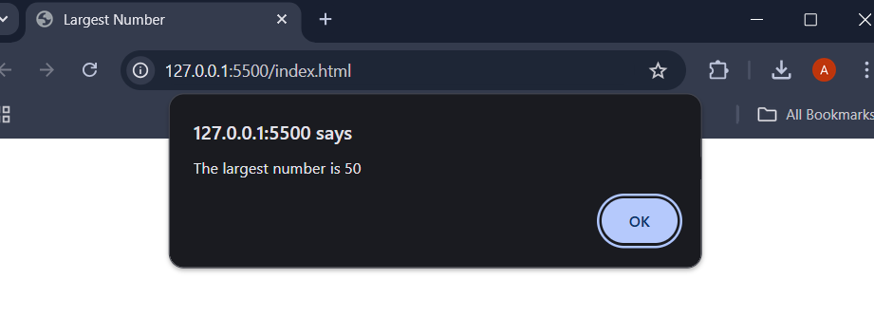

**3. Program to calculate the factorial of a number:**

**Code:**

<!DOCTYPE html>

<html lang="en">

<head>

<title>Factorial</title>

</head>

<body>

<script>

let num = prompt("Enter a number:");

let factorial = 1;

for (let i = 1; i <= num; i++) {

factorial *= i;

}

alert("The factorial of " + num + " is " + factorial);

</script>

</body>

</html>

**Output:**

**4. Program to calculate the sum of any two entered numbers:**

**Code:**

<!DOCTYPE html>

<html lang="en">

<head>

<title>Sum of Two Numbers</title>

</head>

<body>

<script>

let num1 = prompt("Enter first number:");

let num2 = prompt("Enter second number:");

let sum = Number(num1) + Number(num2);

alert("The sum is " + sum);

</script>

</body>

</html>

**Output:**

**Conclusion:**

In this lab, I explored fundamental JavaScript programming concepts through practical exercises. I implemented programs to check if a number is odd or even, find the largest among three numbers, calculate the factorial of a number, and compute the sum of two numbers. These projects helped me understand conditional statements, loops, functions, and user input handling in JavaScript.

Through this lab, I gained hands-on experience in writing efficient code, improving problem-solving skills, and enhancing my understanding of basic mathematical operations using JavaScript. This knowledge will be valuable in developing interactive and dynamic web applications.

**Introduction:**

PHP (Hypertext Preprocessor) is a server-side scripting language widely used for web development. It allows developers to create dynamic web pages, process form data, manage databases, and handle user authentication. PHP is open-source, easy to integrate with HTML, and works efficiently with databases like MySQL. In this lab I learned Basic PHP Syntax, Database Connectivity and **Variables and Data Types.** By the end of this lab, I gained hands-on experience in building dynamic web applications using PHP.

**Software/Tools Used:**

**Xampp:** It is a free and open-source software package that provides an easy way to set up a local web server for development and testing purposes. I am using XAMPP in this lab to create a **local web server** that allows to run and test PHP scripts efficiently

**Vs Code:** Visual Studio Code (VS Code) is a powerful, lightweight code editor used for various programming languages and development tasks. It is used to compile the code.

**Chrome Browser:** Google Chrome is a fast, secure, and widely used web browser developed by Google. It is known for its simple interface, high performance, and strong security features.

**phpMyAdmin:** phpMyAdmin is a web-based database management tool that allows users to interact with MySQL/MariaDB databases using a graphical user interface (GUI). It is included in XAMPP and helps users perform database operations without needing to write SQL commands manually.

**Basic Statements/Commands Used:**

CREATE DATABASE: This creates a new database named **my_database**.

CREATE TABLE: The **CREATE TABLE** statement in SQL is used to create a new table in a database.

SELECT DATABASE: It is used to create new database

INSERT INTO: The **INSERT INTO** statement is used to add new records (rows) into a table in a database.

**1. Create a database named ‘computer_science’:**

**Code:**

<?php

$servername = "localhost";

$username = "root";

$password = "";

$dbname = "computer_science";

$conn = new mysqli($servername, $username, $password);

if ($conn->connect_error) {

 die("Connection failed: " . $conn->connect_error); }

$sql = "CREATE DATABASE $dbname";

if ($conn->query($sql) === TRUE) {

 echo "Database '$dbname' created successfully."; } else {

 echo "Error creating database: " . $conn->error; }

$conn->close();

?>

Output:

**2. Create a table and insert 5 records:**

**Code:**

<?php

$servername = "localhost";

$username = "root";

$password = "";

$dbname = "computer_science";

$conn = new mysqli($servername, $username, $password, $dbname);

if ($conn->connect_error) {

die("Connection failed: " . $conn->connect_error);

}

$sql_create_table = "CREATE TABLE Students (

roll_number INT AUTO_INCREMENT PRIMARY KEY,

name VARCHAR(50),

gender VARCHAR(10),

address VARCHAR(100),

contact VARCHAR(15)

)";

if ($conn->query($sql_create_table) === TRUE) {

echo "Table Students created successfully.<br>";

} else {

echo "Error creating table: " . $conn->error . "<br>";

}

$sql_insert_data = "INSERT INTO Students (name, gender, address,

contact) VALUES

('Anil Kumar', 'Male', 'Itahari, Sunsari, Nepal', '9845XXXXXX'),

('Bini Sharma', 'Female', 'Khanar, Sunsari, Nepal', '9855XXXXXX'),

('Sushil Prasad', 'Male', 'Dharan, Sunsari, Nepal', '9866XXXXXX'),

('Richa Rai', 'Female', 'Duhabi, Sunsari, Nepal', '9811XXXXXX'),

('Ashish Chaudhary', 'Male', 'Jhumka, Sunsari, Nepal', '9877XXXXXX')";

if ($conn->query($sql_insert_data) === TRUE) {

echo "Records inserted successfully.";

} else {

echo "Error inserting records: " . $conn->error;

}

$conn->close();

?>

**Output:**

**3. Fetch and display records in tabular form:**

**Code:**

<?php

$servername = "localhost";

$username = "root";

$password = "";

$dbname = "computer_science";

$conn = new mysqli($servername, $username, $password, $dbname);

if ($conn->connect_error) {

die("Connection failed: " . $conn->connect_error);

}

$sql = "SELECT roll_number, name, gender, address, contact FROM

Students";

$result = $conn->query($sql);

if ($result->num_rows > 0) {

echo "<table border='1' cellpadding='10' cellspacing='0'>

<tr>

<th>Roll Number</th>

<th>Name</th>

<th>Gender</th>

<th>Address</th>

<th>Contact</th>

</tr>";

while($row = $result->fetch_assoc()) {

echo "<tr>

<td>" . $row["roll_number"] . "</td>

<td>" . $row["name"] . "</td>

<td>" . $row["gender"] . "</td>

<td>" . $row["address"] . "</td>

<td>" . $row["contact"] . "</td>

</tr>";

}

echo "</table>";

} else {

echo "No records found.";

}

$conn->close();

?>

**Output:**

**Conclusion:**

In this PHP lab, I successfully learned and implemented the fundamentals of PHP programming and database management using XAMPP, phpMyAdmin, and VS Code. By setting up a local development environment, I was able to write, execute, and debug PHP scripts efficiently.

Through phpMyAdmin, I managed MySQL databases, performed CRUD operations, and executed SQL queries, enhancing my understanding of database interactions with PHP. Using VS Code, I wrote clean, well-structured PHP code with the help of syntax highlighting and debugging tools.